OBJECT ORIENTED PROGRAMMING CW- GROUP WORK
Group members
- Peter Matovu
- Leon Tusiime
- Abraham Tukie
- Robert Paschal

GitHub Repository Link:

1. Question One – Part A (Single Student Grading)
Program Name: GradingSingleStudent.java
Description:
- Prompts user to enter a student’s score (0–100).
- Uses if-else-if statements to determine the Uganda O-Level grade (1–9) and remark (D1 to F).
- Displays the score, grade, and remark.
- Handles invalid scores (outside 0–100) with an error message.

- Screenshot of program running with a valid score; input 85 - output Grade 1, D1
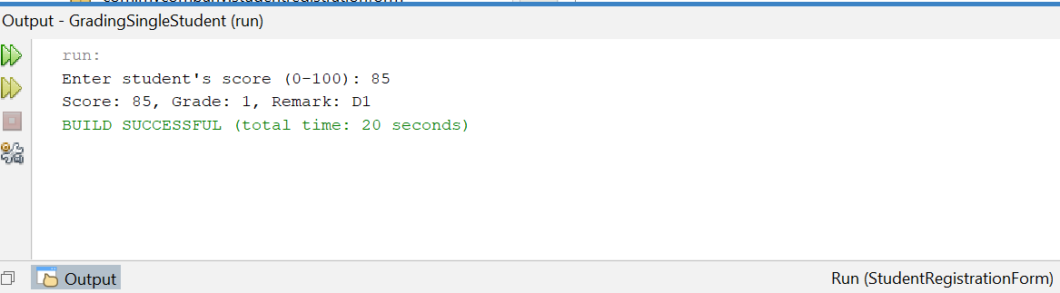

- Screenshot of program running with an invalid score; input 106 - error message
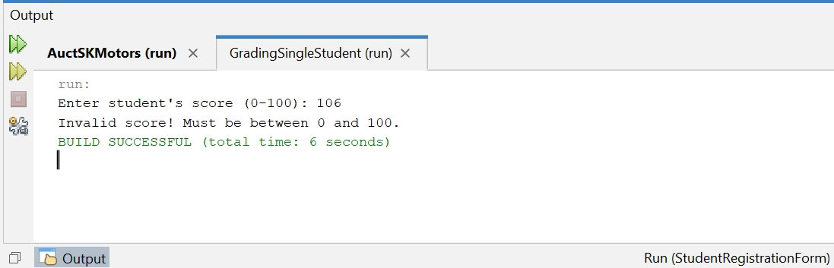

2. Question One – Part A (Modified to grade 5 Students with Summary)
Program Name: GradingFiveStudents.java
Description:
- Modified version of the above program.
- Uses a while loop to accept and process scores for exactly 5 students.
- Re-prompts on invalid scores without counting them.
- After-all 5 valid entries, displays a summary showing the number of students per grade (1 to 9).

- Screenshot showing inputs for 5 students and individual grade/remark outputs
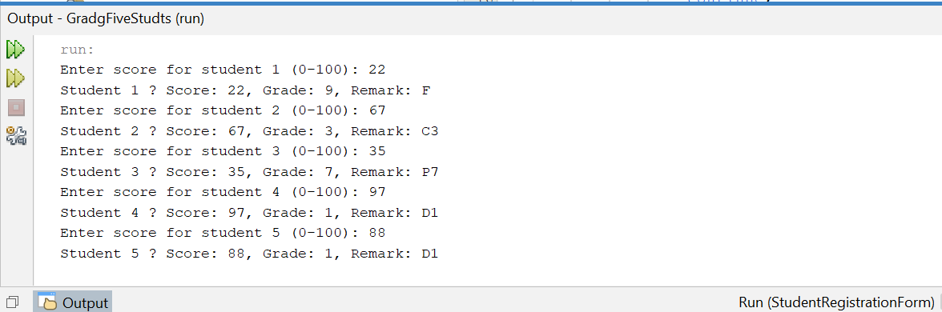

- Screenshot of the final Grade Summary table, for example; Grade 1: 2 students, Grade 9: 1 student
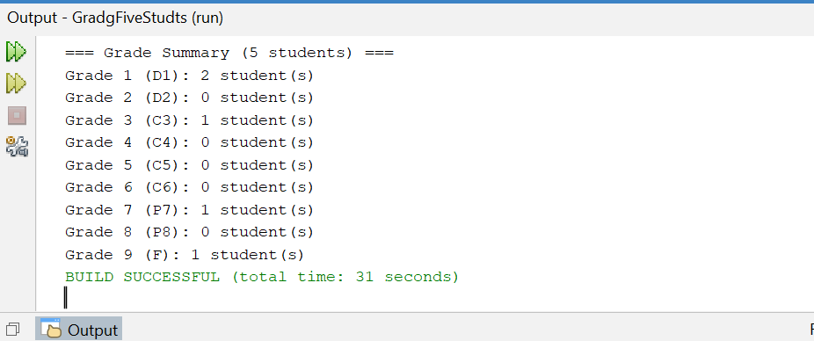

3. Question One – Part B (SK Motors Auction)
Program Name: AuctSKMotors.java
Description:
- Accepts vehicle registration number, cost (UGX), and outstanding balance (UGX).
- Accepts details for 3 bidders (name and bid amount in UGX).
- Identifies the bidder with the highest bid as the winner.
- Accepts total expenses (e.g. repairs/transport).
- Calculates and displays profit or loss (highest bid – cost – expenses – balance).

- Screenshot of full program output including vehicle details, 3 bidders, winner, and profit/loss result
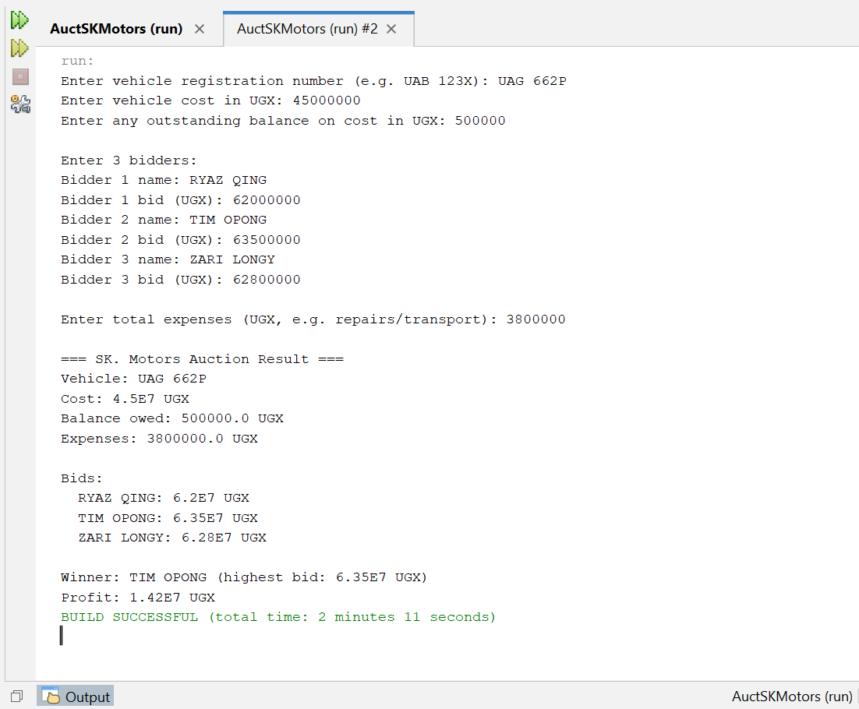

4. Question Two – New Student Registration Form (GUI)
Program Name: StudentRegistrationForm.java
Description:
- JavaFX desktop application with GUI matching the required form layout.
- Fields: Student First Name, Student Last Name, Email Address, Confirm Email Address, Password, Confirm Password, Date of Birth (3 combo boxes: SelectYear, SelectMonth, SelectDay), Gender (Male/Female radio buttons), Department (choice box with full names).
- Validates all fields (required, email format, password rules, emails match, passwords match, age 16–60, selections made).
- Displays formatted record in text area on successful submit (e.g. 2026-00001 | Okello Allan | Male | Computer Science and Engineering | 2005-06-15 | okello_allan@example.com).
- Appends record to students.csv file with auto-generated ID (2026-xxxxx counter).
- Shows success alert on save, error alert + red label on validation failure.
- Cancel button clears the form.

- Screenshot of empty form showing all labels, combo placeholders, radio buttons, department list
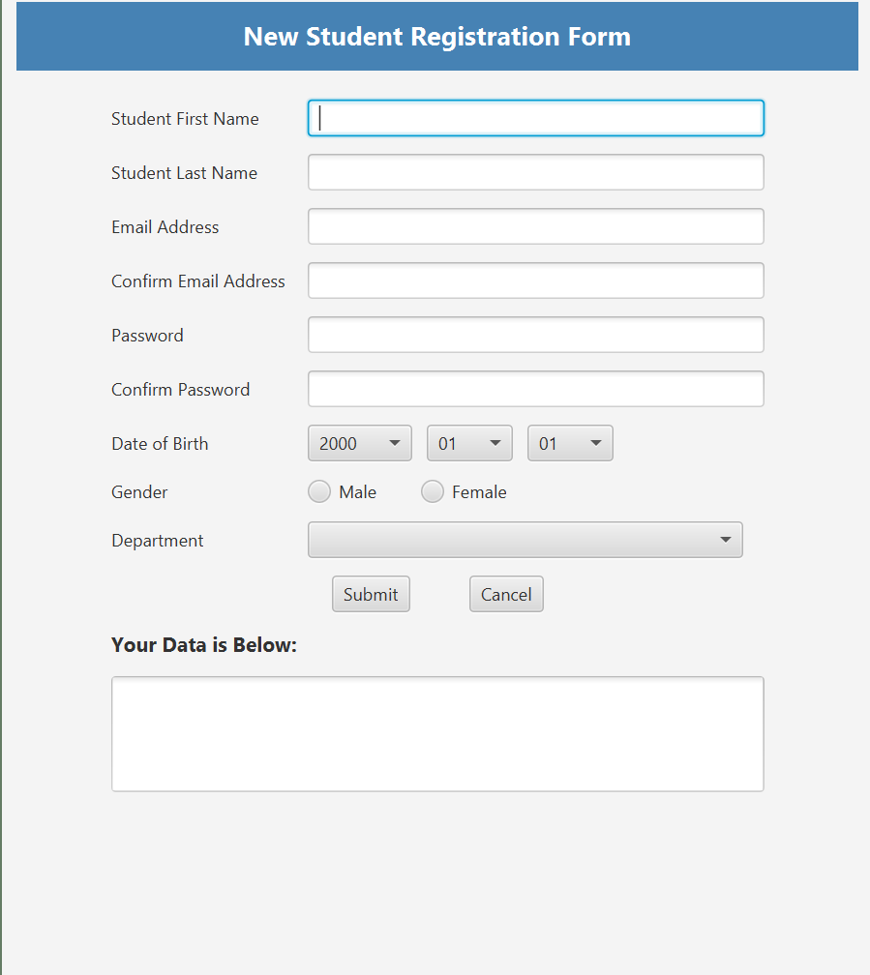

- Screenshot of form filled with valid data just before submit button is used
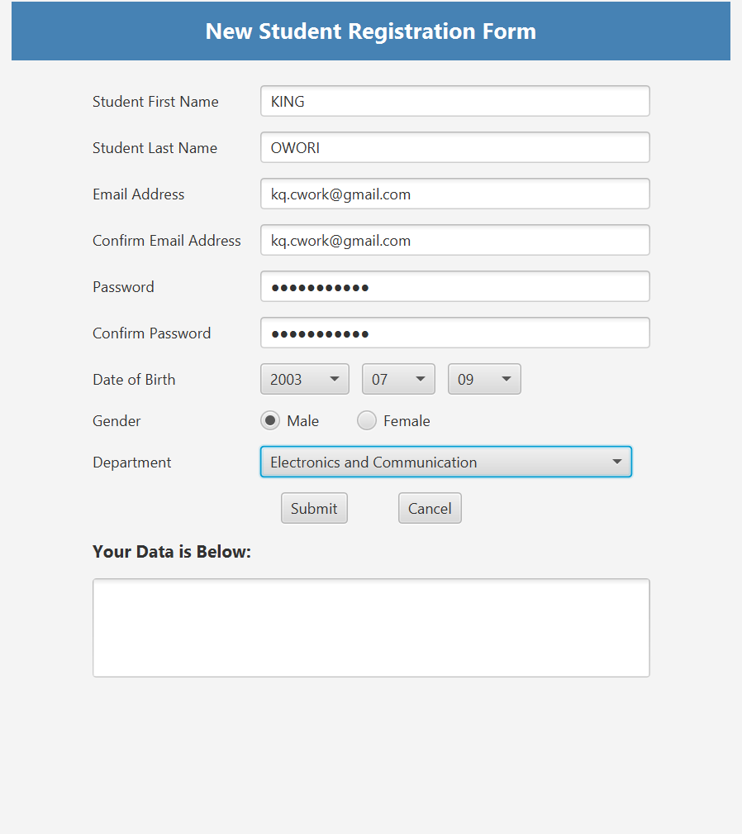

- Screenshot of successful submission record displayed in text area & success alert
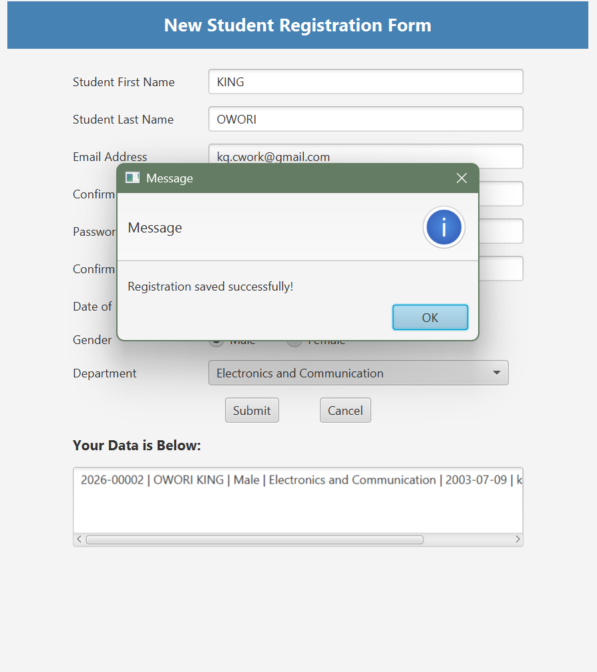

- Screenshot of validation error; mismatched email addresses and invalid password
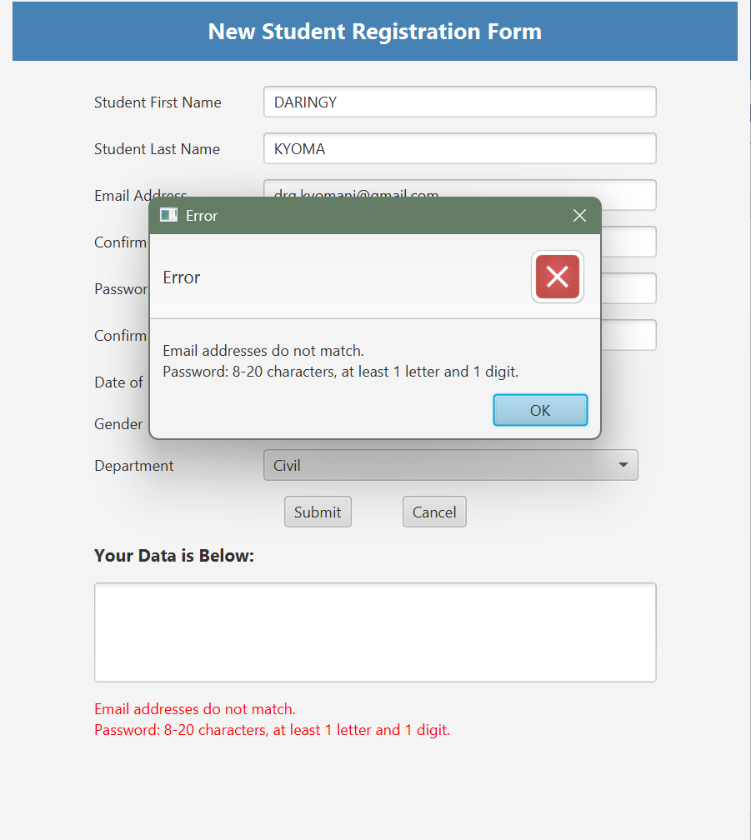

- Screenshot of students.csv file opened in Notepad showing saved records
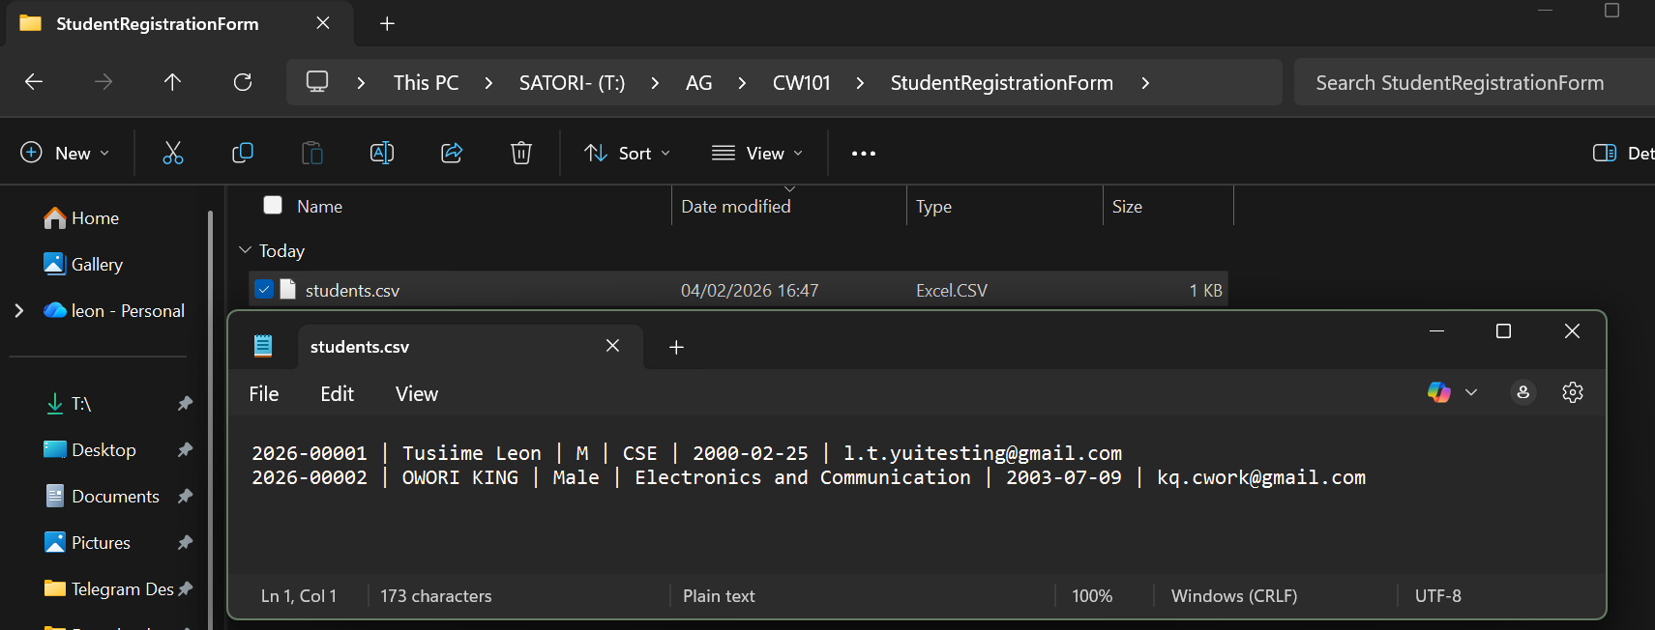

Details on each program;
We developed the programs with Apache NetBeans IDE 25 with JDK 25.
- Console programs (Question 1A & 1B): Right-click .java file - Run File
- GUI program (Question 2): Right-click project – Run. Fill form, submit to see result and generate students.csv in project folder.

Check-listed Files included in GitHub:
- GradingSingleStudent.java
- GradingFiveStudents.java
- AuctSKMotors.java
- StudentRegistrationForm.java
- students.csv
- This Word document with screenshots

